**ASSISTED PRACTICE EMP :2587303**

**NAME:R.HIMABINDU**

1. Demonstrate how to set up Postman

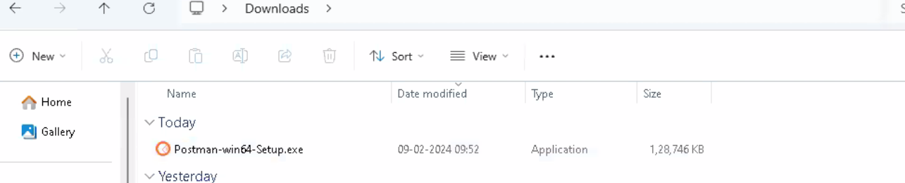

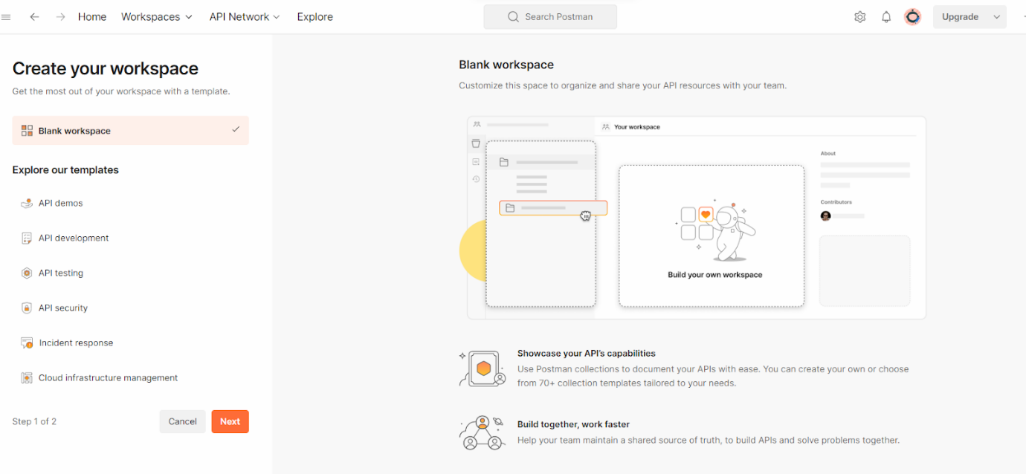

1. Demonstrate how to create the first API request.

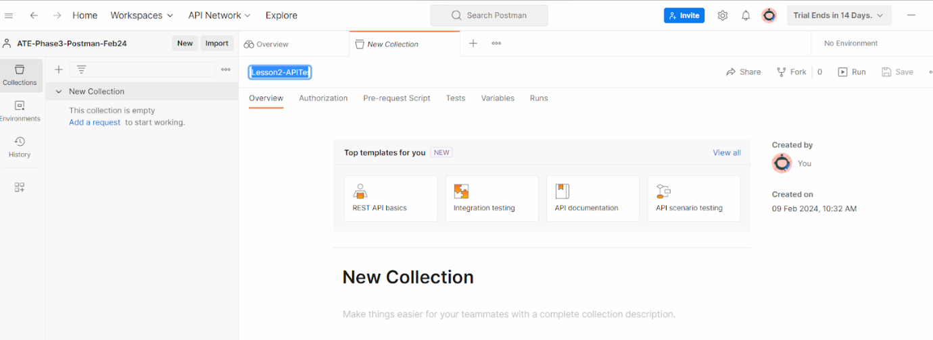

1. Demonstrate how to use Postman with SOAP.
2. Explain how to work on GET requests, with an example.

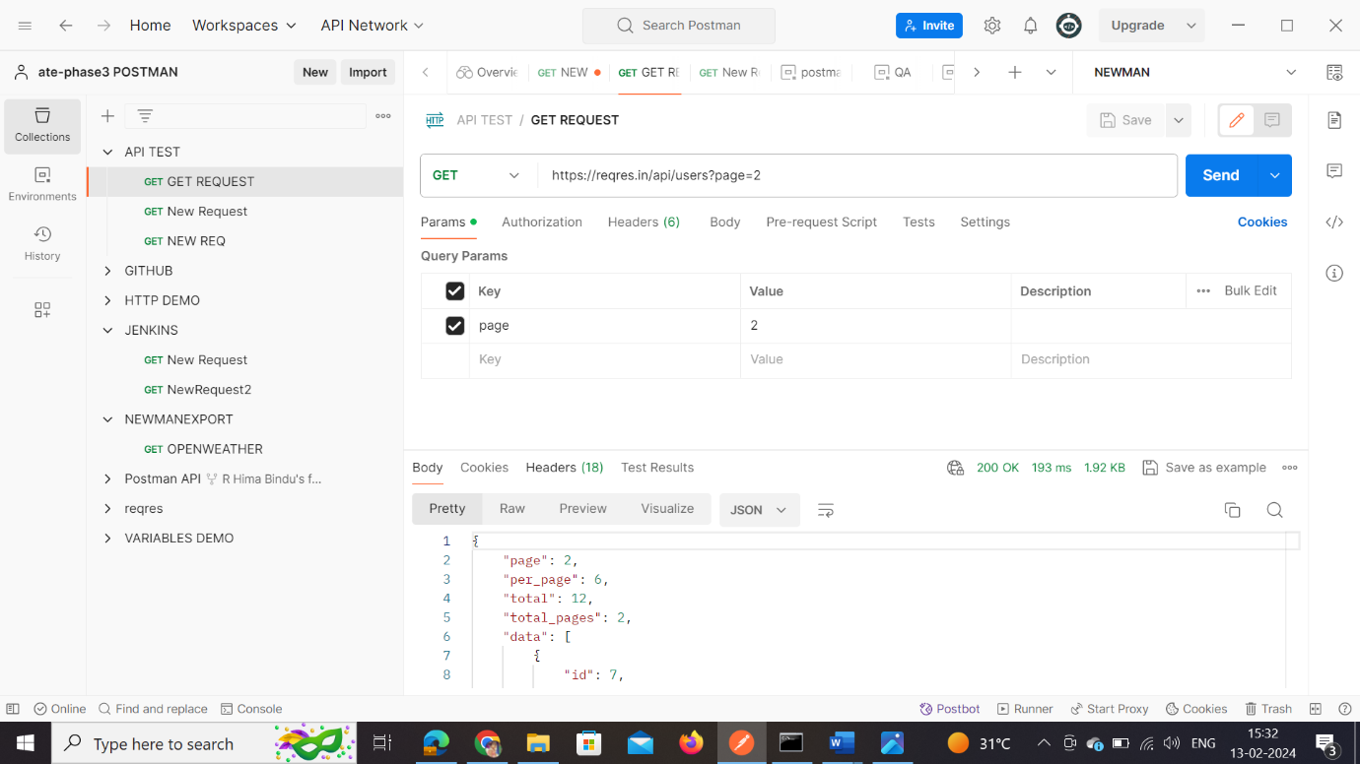

1. Demonstrate how to work with POST requests.

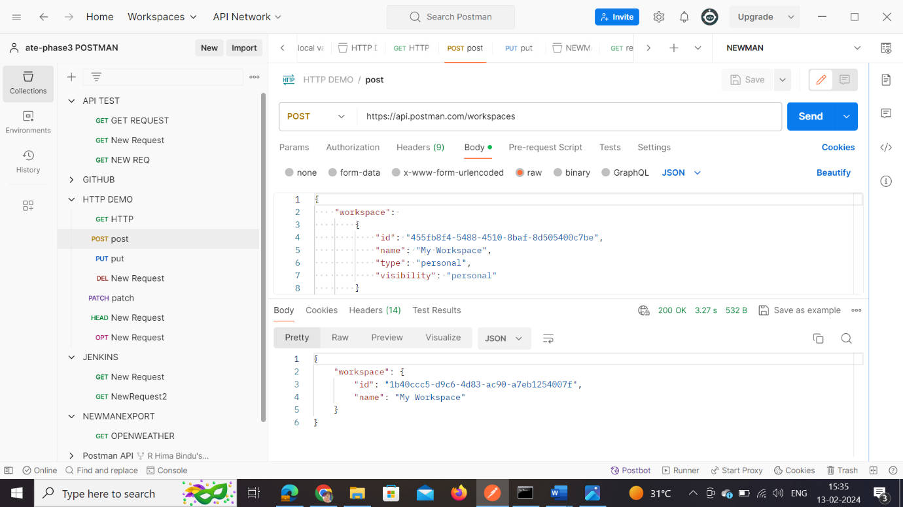

1. Demonstrate how to parameterize requests.

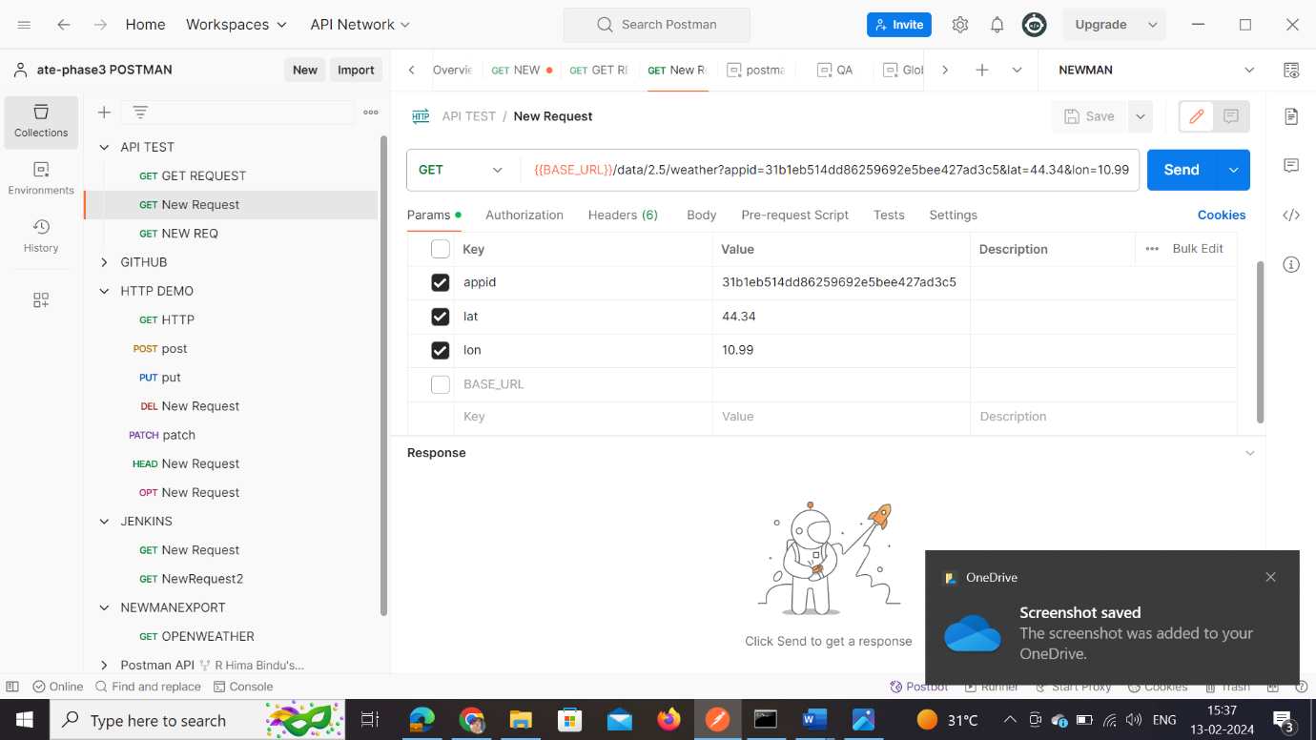

1. Demonstrate how to create a Collection.



1. Demonstrate how to run a Collection using Collection Runner.

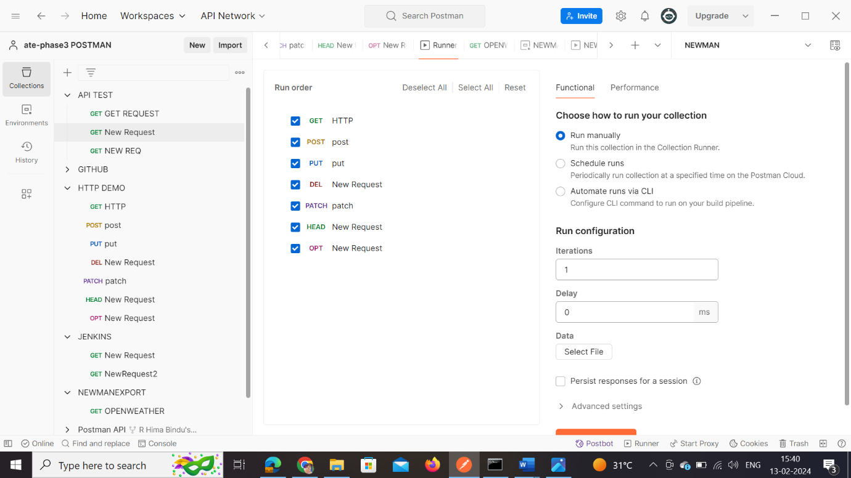

1. Demonstrate how to work with variables in Postman.

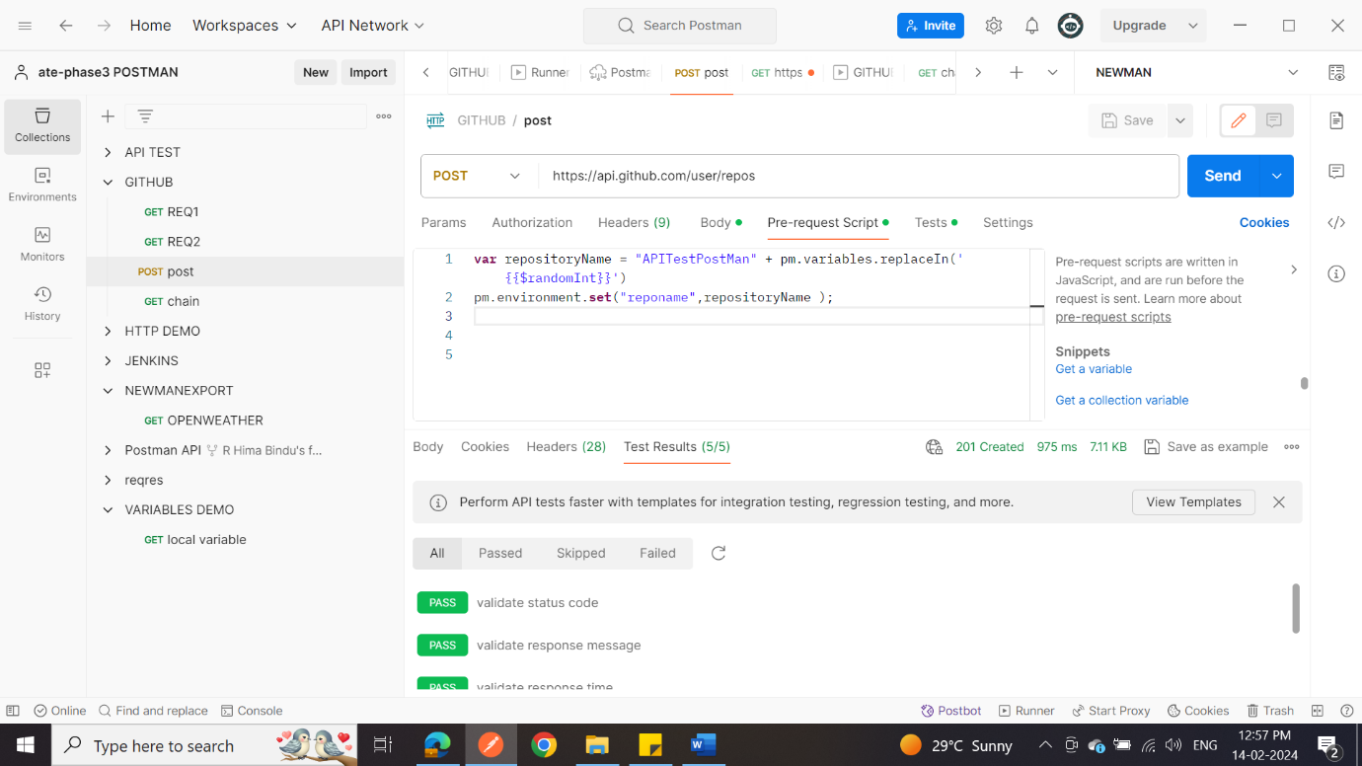

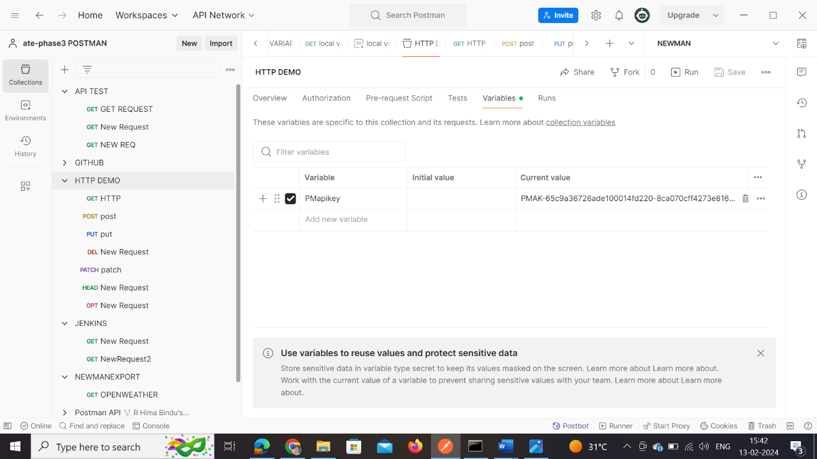

1. Create a request, and collections and variables using Postman.

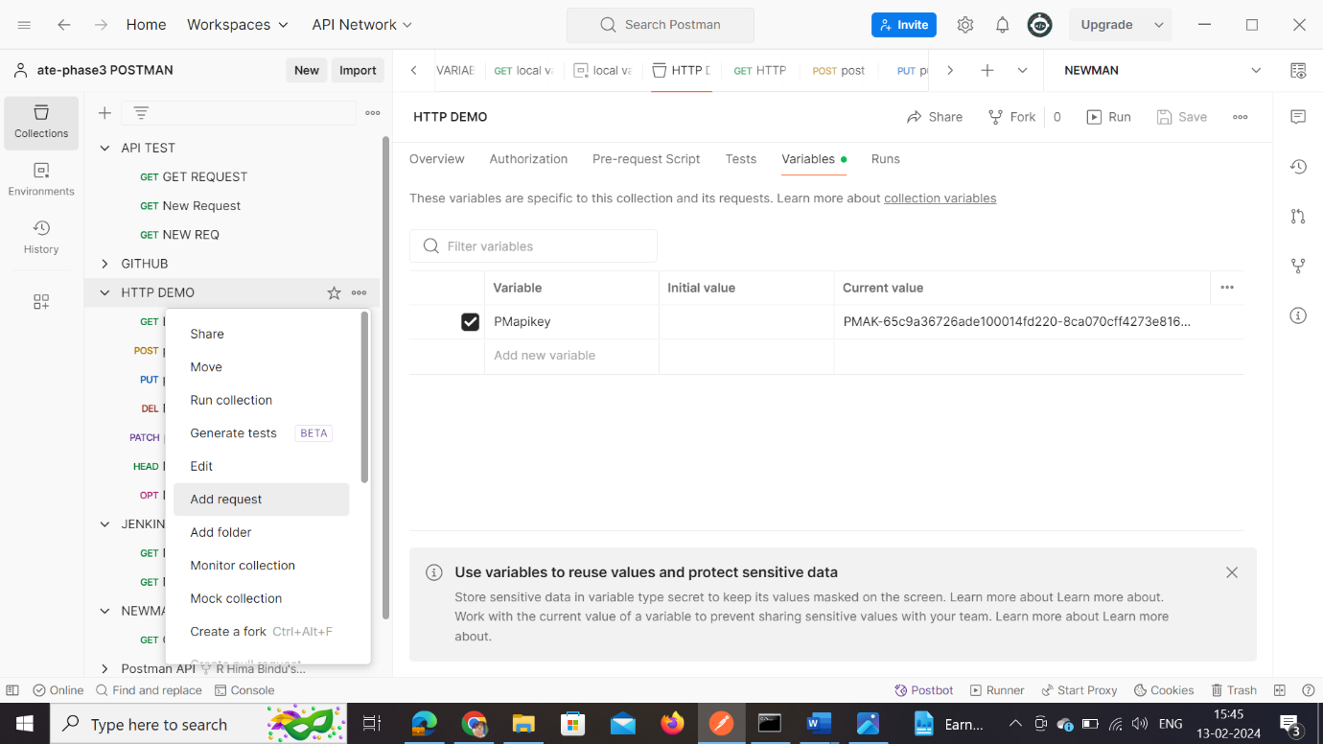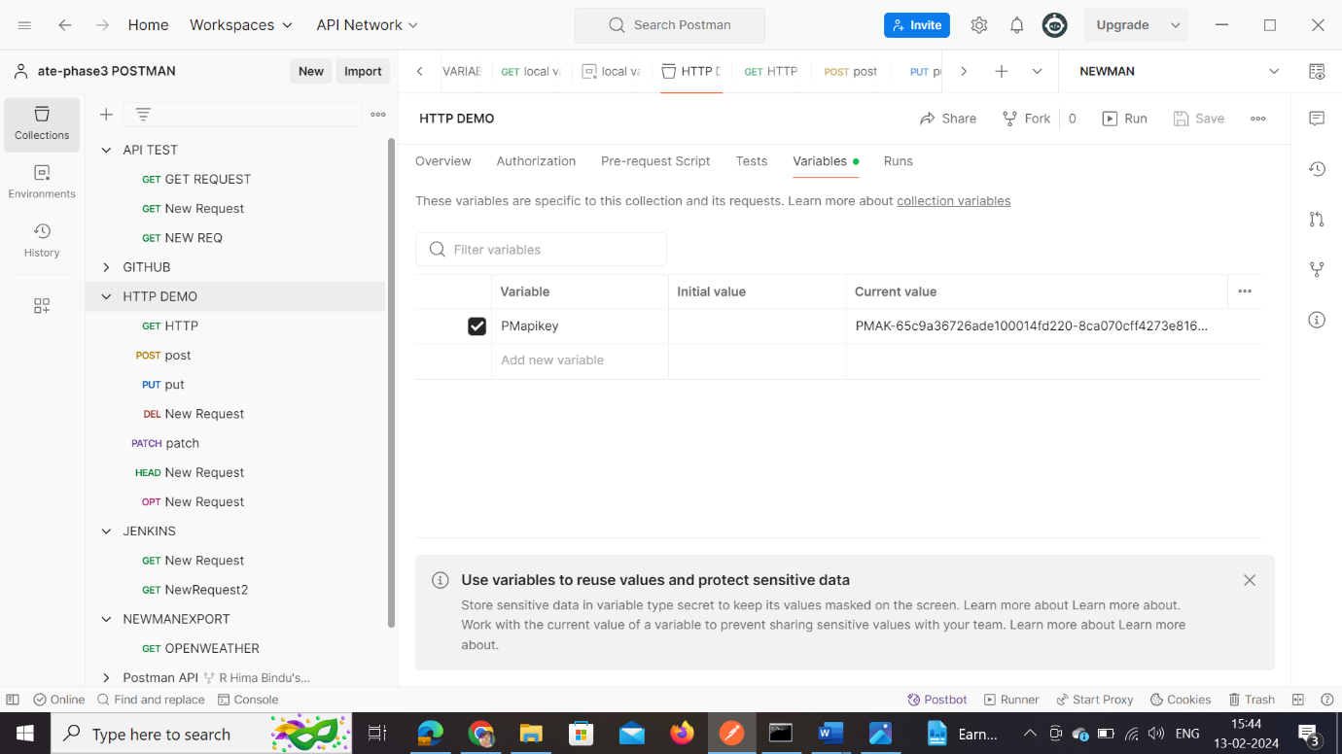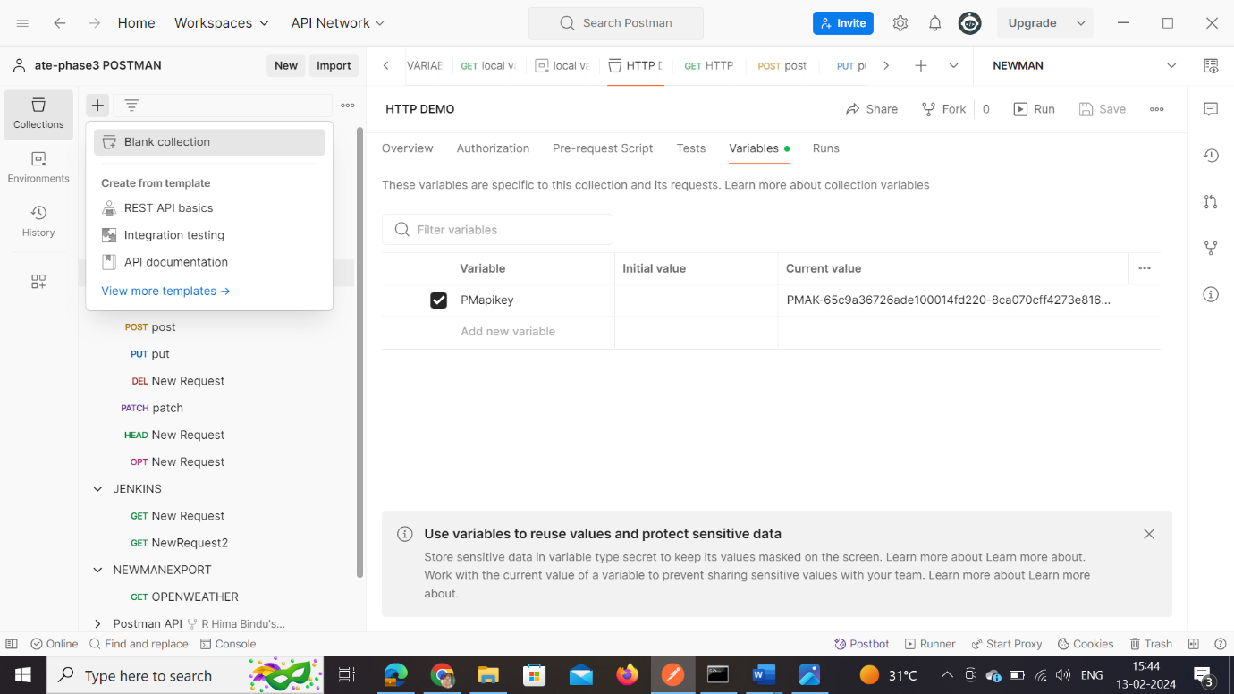

1. Demonstrate how environments are used in Postman.

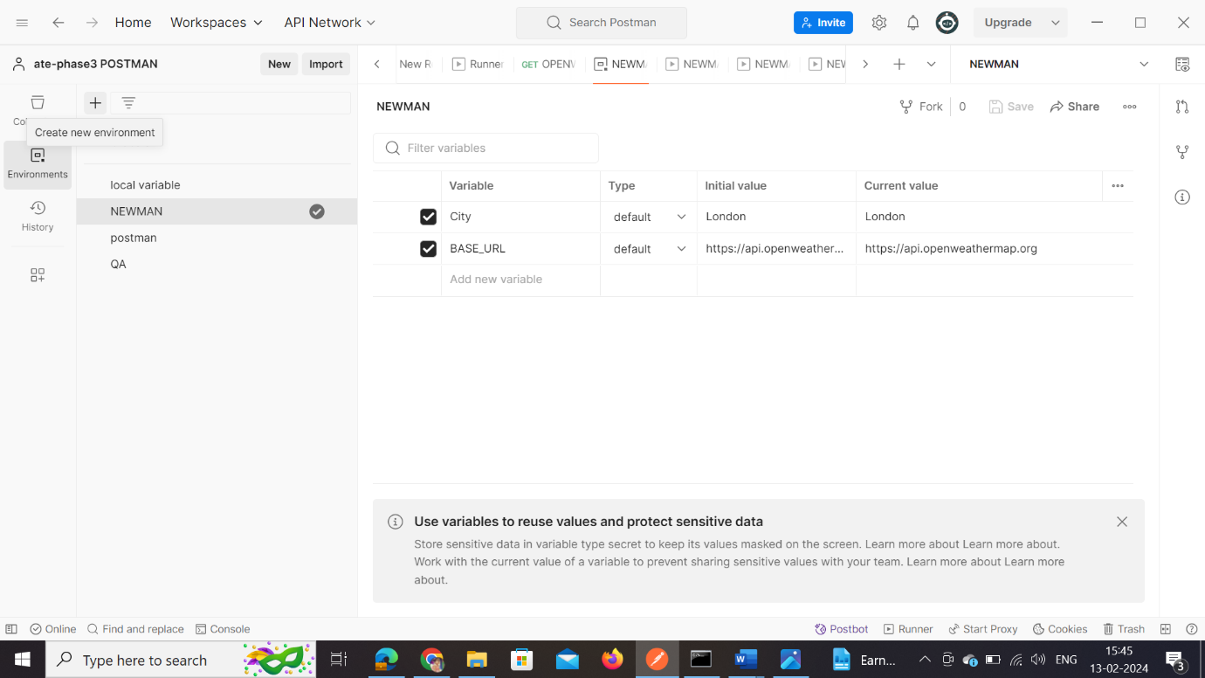

1. Demonstrate how test scripts are written in Postman.

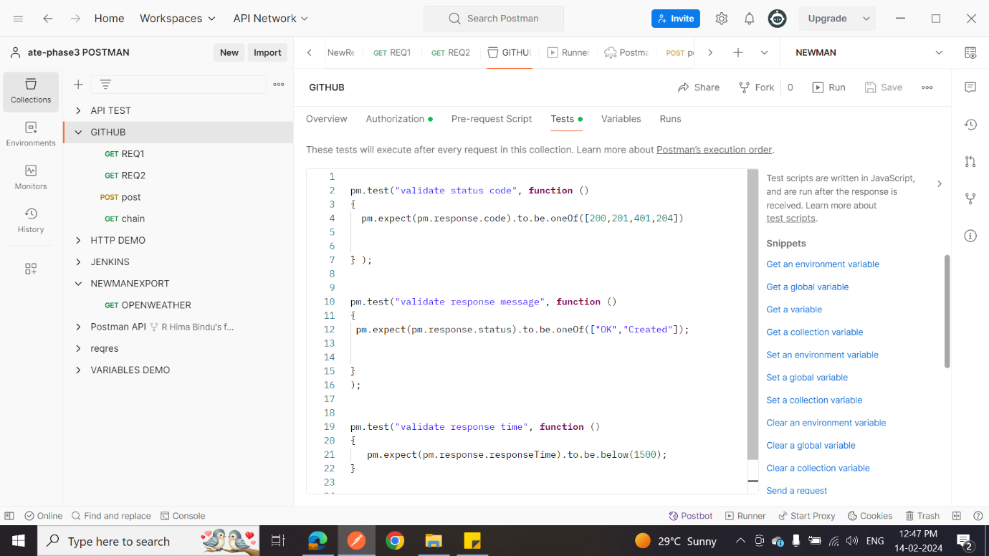

1. Demonstrate how Postman is used with Jenkins.

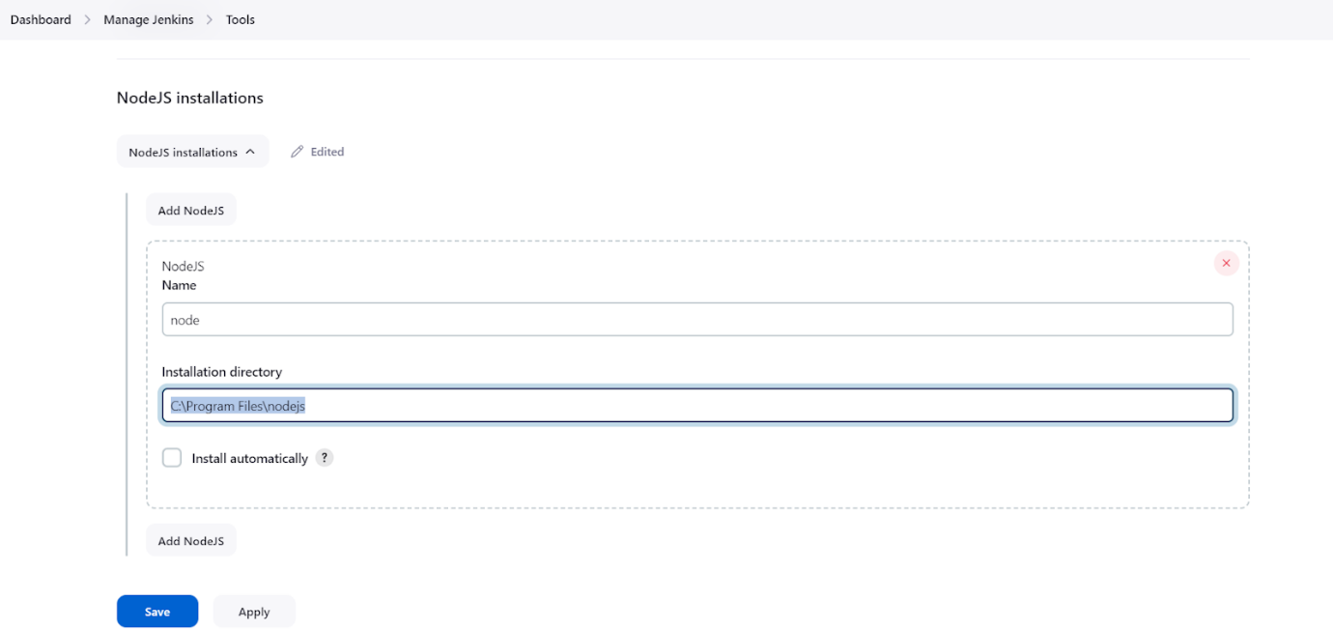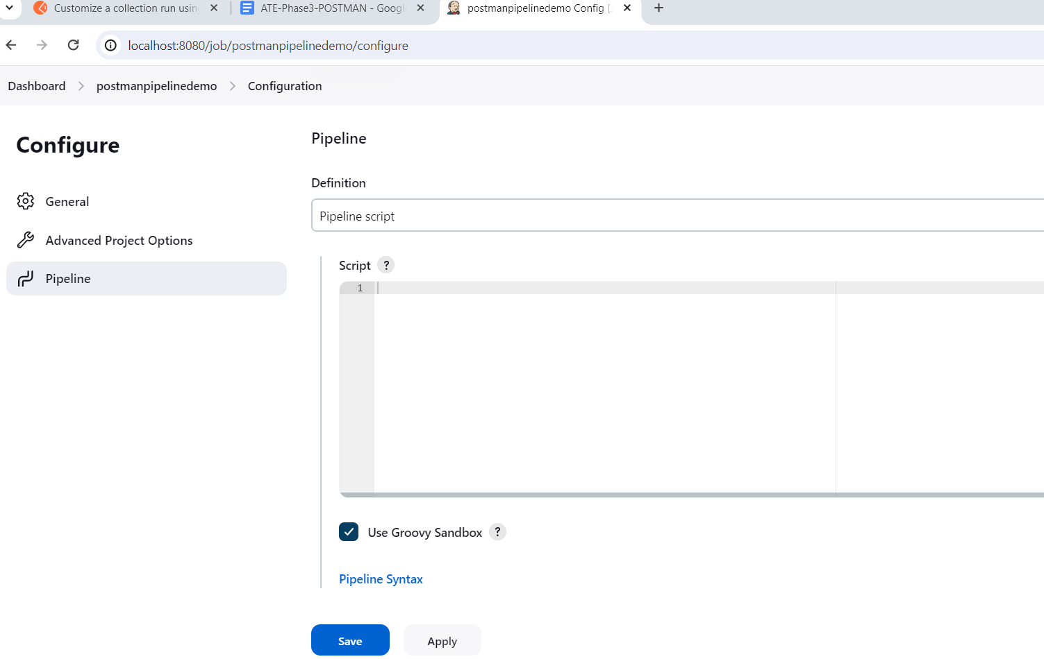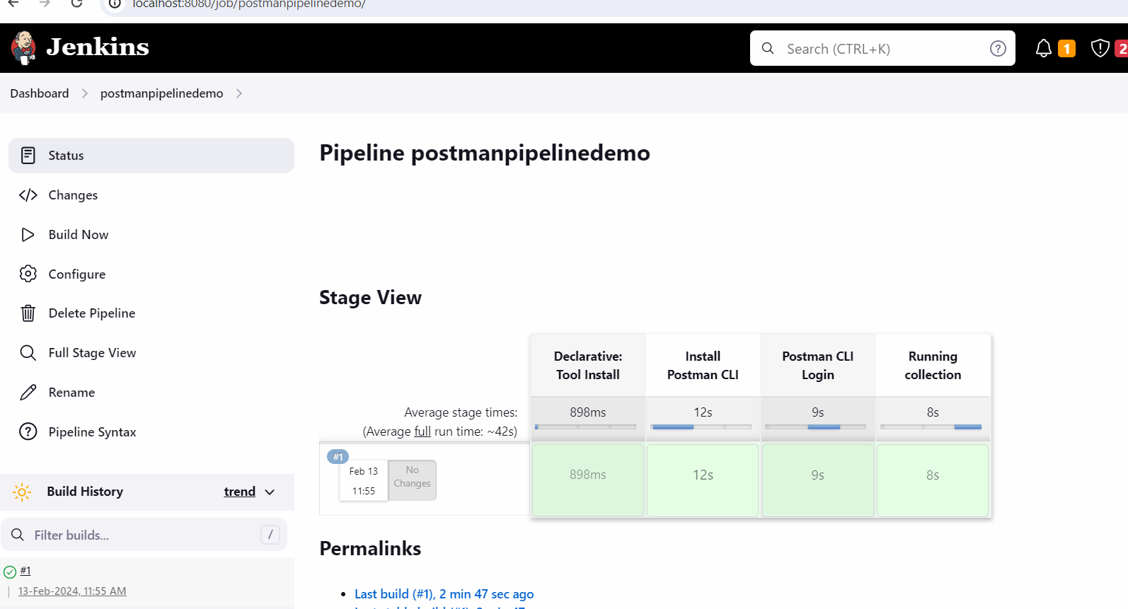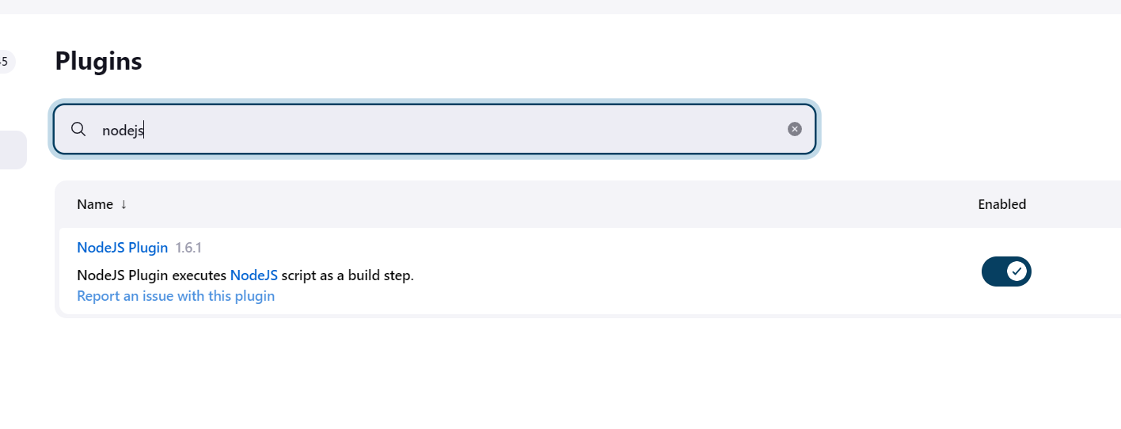

1. Illustrate workspaces in Postman using an example.

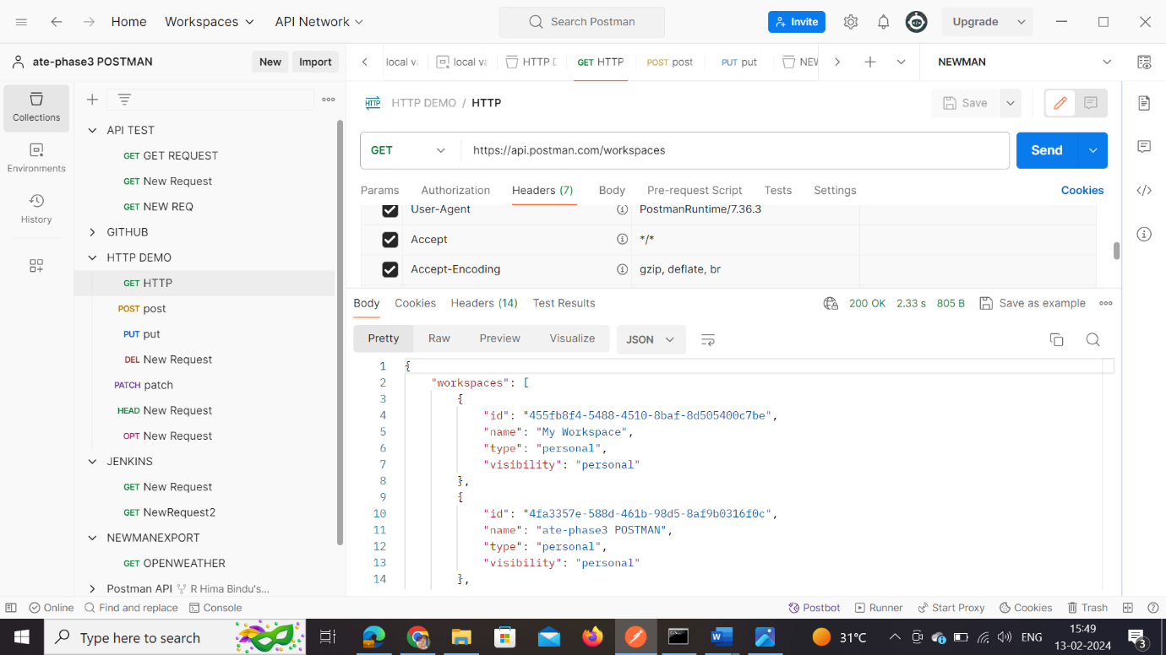

1. Demonstrate how monitors are used.

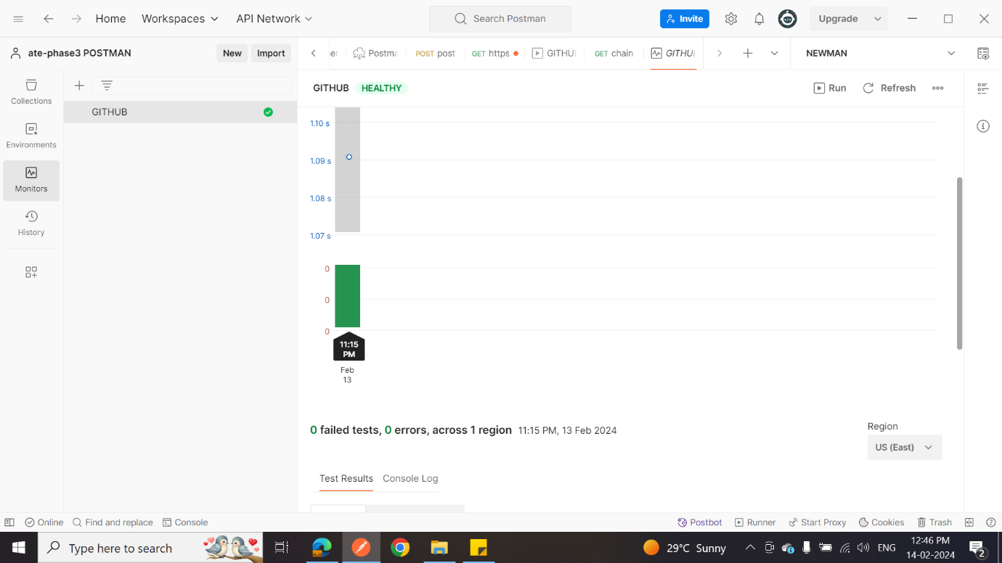

1. Demonstrate how to perform API documentation.

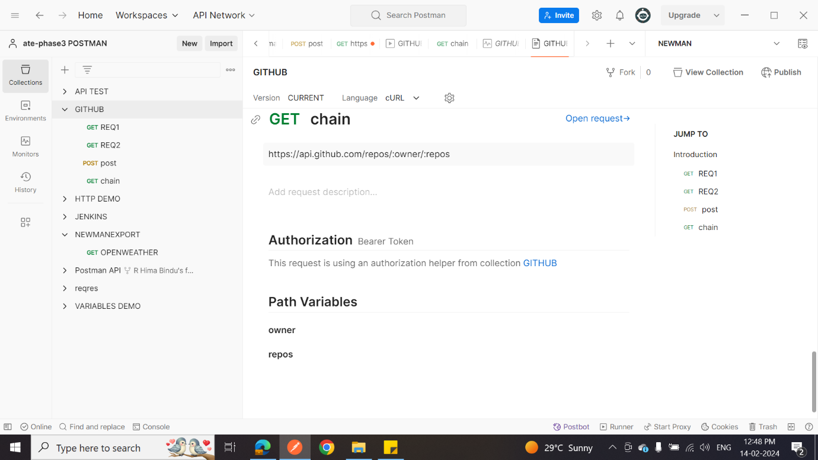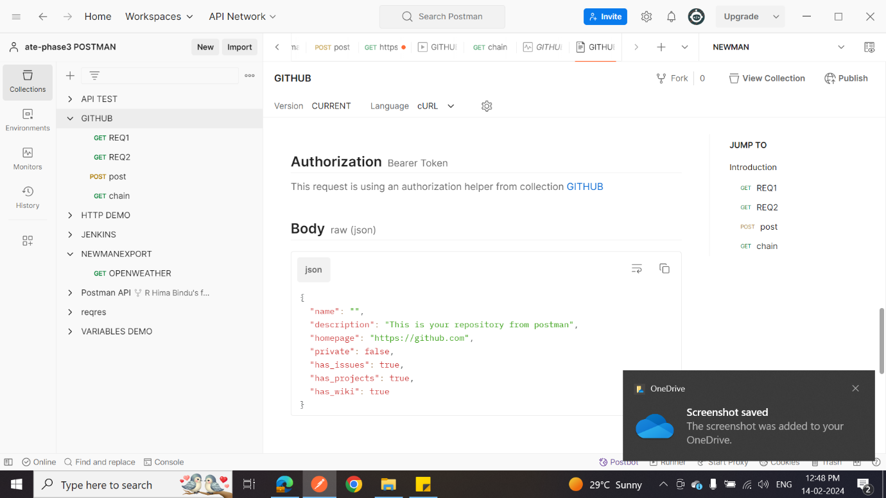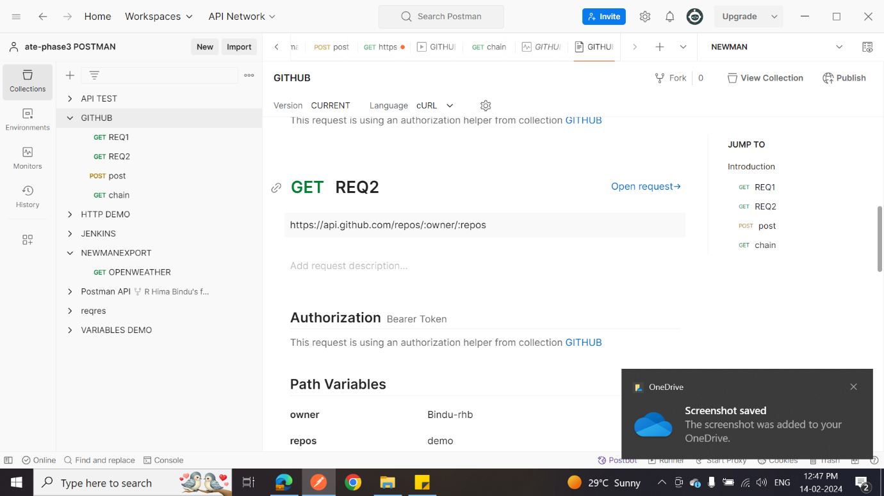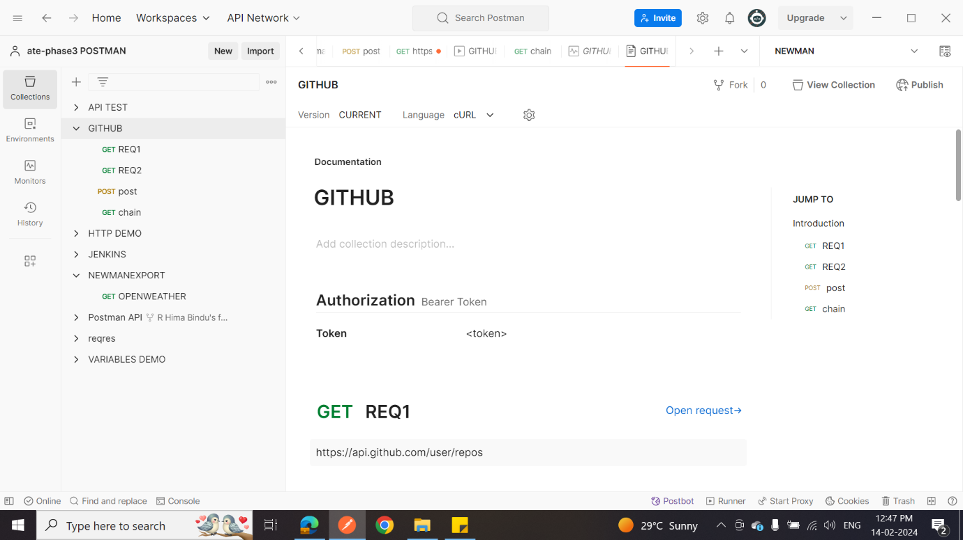

1. Demonstrate how to get data from CSV and JSON.

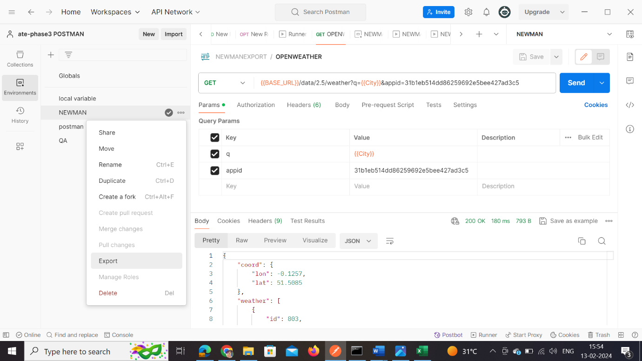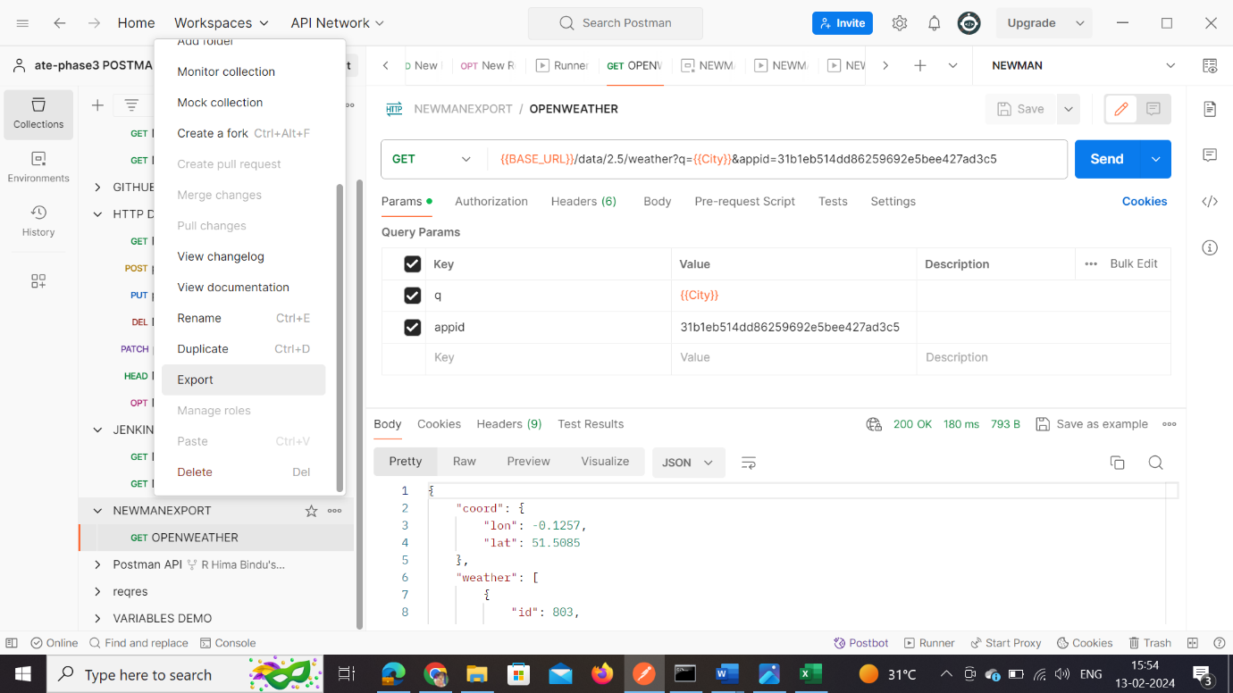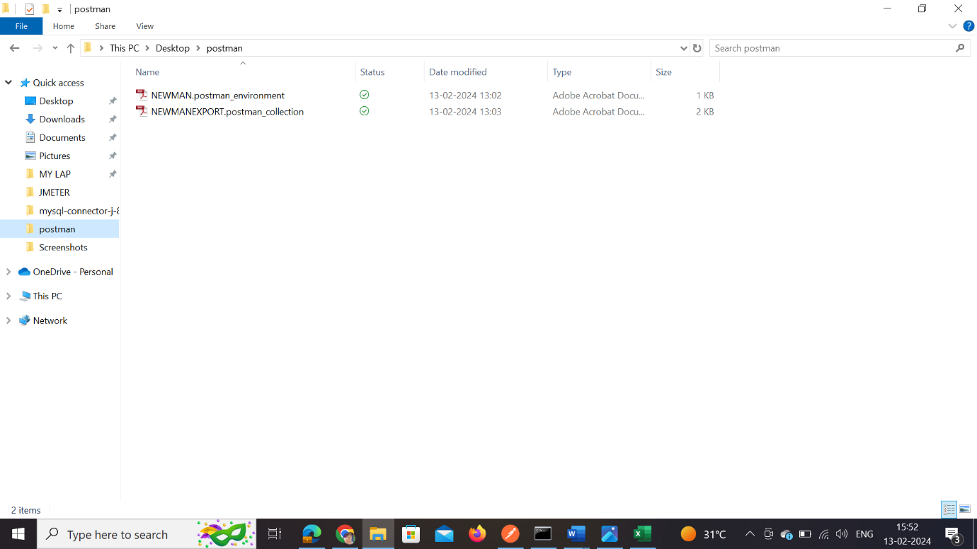

1. Demonstrate how to run a collection remotely with URL.

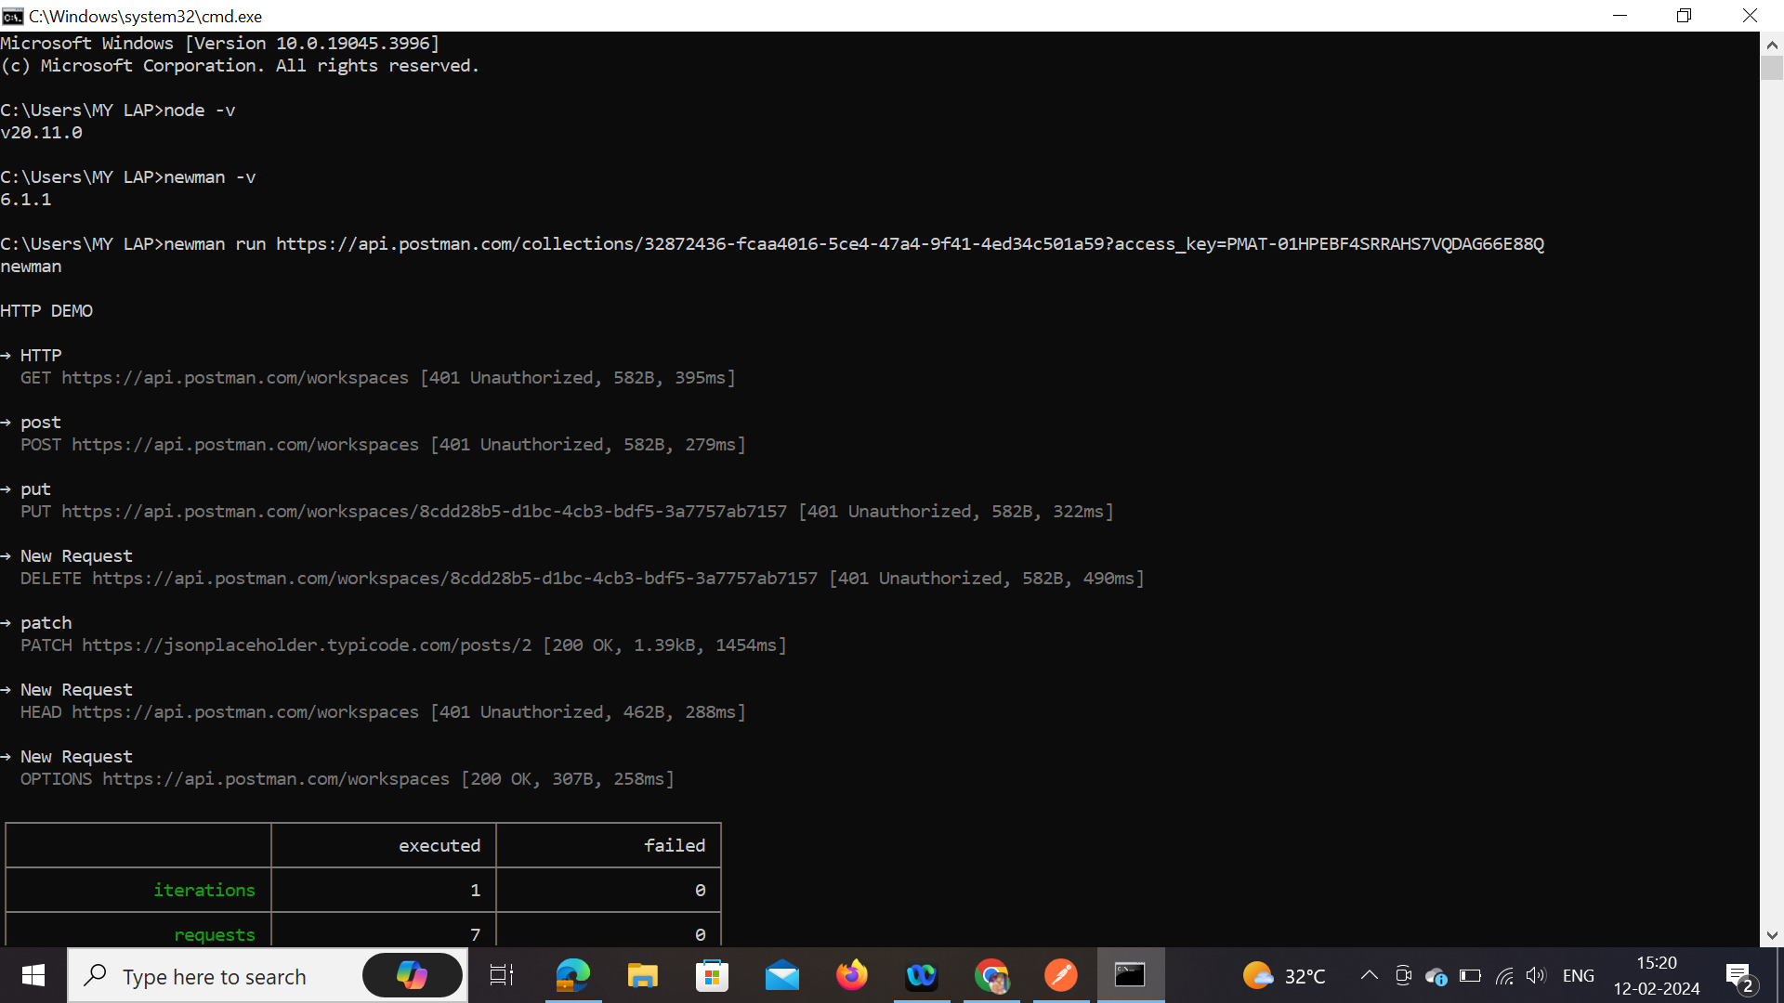

1. Demonstrate how to run SOAP requests in Postman.
2. Demonstrate API Chaining and REST in Postman.

